Press Release

GeoWine
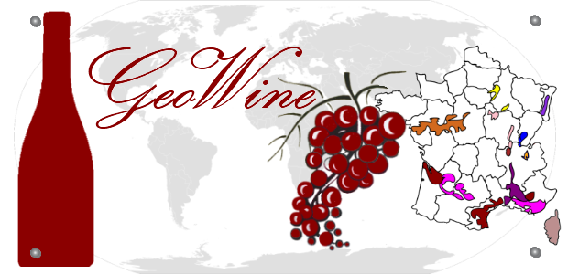
@
http://apps.microsoft.com/windows/app/geowine/54cd98ed-8242-4fbe-9069-065de218c373
GeoWine is an original and innovative graphical quiz, a unique concept of its kind.

It is a game to learn but also entertaining. Allowing you to evaluate and improve your knowledge of wine regions and appellations.

The goal is to get the maximum points within the minimum amount of time.

While achieving the best scores and to compete with your friends you will grow your knowledge of French and world wine regions, their names and different varieties.

“His lips drink water but his heart drinks wine” ― E.E. Cummings

A lively quiz to be played without moderation

