“i- PROOF STUDY ZONE”

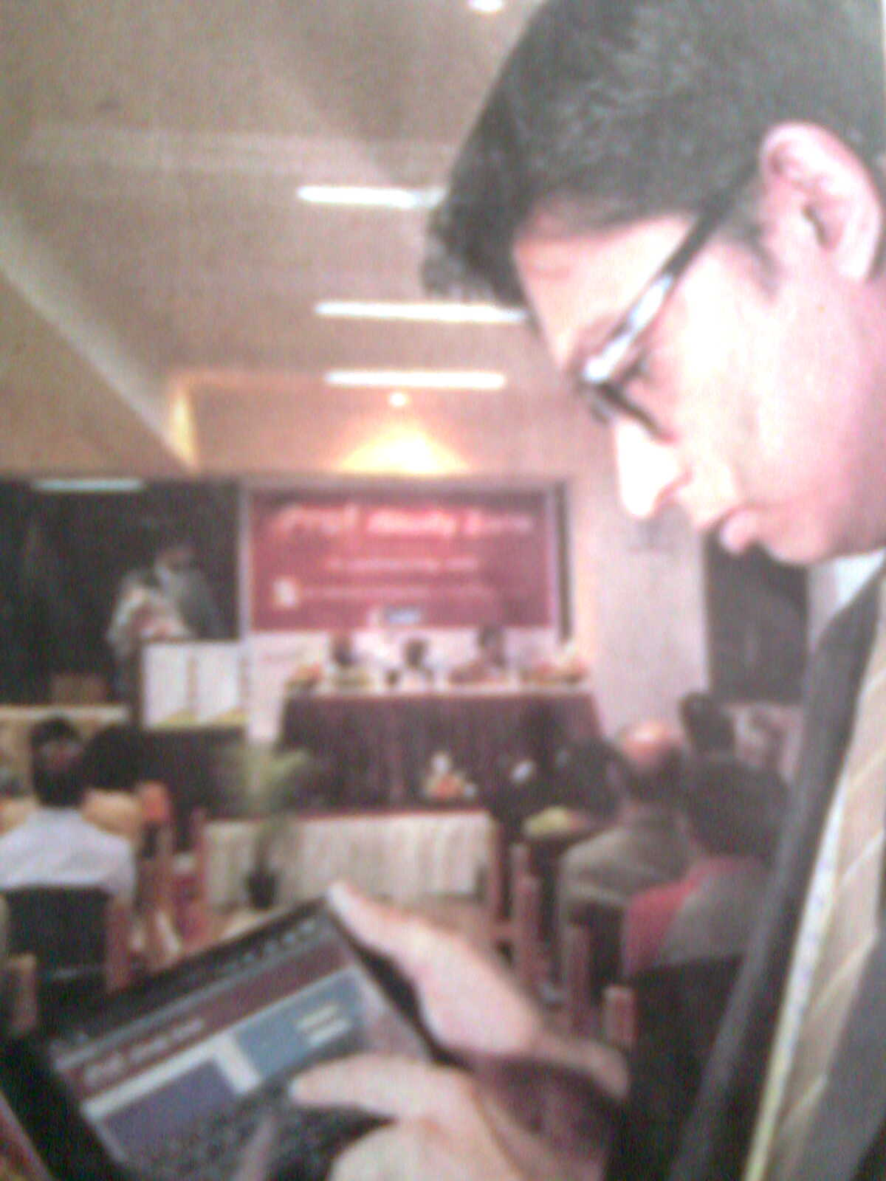

Now a days we are easily learning the computer knowledge, and how to operate the computers.
In the same way, The “i-proof learning solution india” developed an learning machine namely “i-poof study zone”
This study zone is 7”inchs and having touch screen facility also having a information about study materials where they collected by education institutes.
G.R.VIDYA DEEP, BUSINESS MANAGEMENT ACADEMY.GANAGNAGAR B’LORE.having a shared in develpoping this machine. The i-proof having much more information about Audio, video, study materials, question papers etc..
We can learn the study materials prepared by IIT JEE coching centre where it is located e-learning centre through out in india like delhi,pune, nagpur, jaipur, baroda, ahmadaba, patiyala, nasik, ranchi, patna such like 40 cities.
This i-proof study zone machine is available at low cost of RS 14,900/-only
We can exchange our matters throughing using this new facility and also once we can download the study materials or any other agin we can easily watch it with out any other internet connection.

